Tab 1



Mtel (Thailand) Co., Ltd.

For

T.C.C. Technology Co., Ltd.

One Bangkok Mobile Application
Integration Live Chat, FAQ, Email OTP and Notification with ConnectX
Scope of work Document
To
T.C.C. Technology Co., Ltd.

Total 20 sheets (w/h cover sheet)
 | PROJECT NAME | JOB NO. | DOCUMENT NO. | REV.
 | One Bangkok Mobile Application - Integration Live Chat, FAQ, Email OTP and Notification with ConnectX  Scope of work document |  |  | 01

Content table
1. Document Purpose 3
2. Project Background & Overview 4
2.1. Objectives 4
3. Scope (Functional Scope) 5
3.1. Live Chat Integration 5
3.2. FAQ Integration 6
3.3. Email OTP 6
3.4. Support ConnectX Notification 7
4. Limitations 7
5. Out of Scope 7
6. Responsibilities 8
7. Variables and Constraints 9
7.1. External Factors 9
7.2. Internal Constraints 9
8. Deliverables 10
8.1. Functional Deliverables 10
8.2. Technical Deliverables 10
8.3. Documentation Deliverables 10
8.4. Testing Deliverables 10
8.5. Deployment & Handover Deliverables 10
Appendix 1: Live Chat Design Flow 12
Appendix 2: FAQ Design Flow 16
Appendix 3: Email OTP 19

One Bangkok Mobile Application - Integration Live Chat, FAQ, Email OTP and Notification with ConnectX
To
T.C.C. Technology Co., Ltd.
This document serves as the official Statement of Work (SOW) for the integration of Live Chat, FAQ, Email OTP, and Notification services within the One Bangkok Mobile Application, powered by the ConnectX platform. The purpose of this initiative is to centralize customer support interactions and communication services into a unified ecosystem to enhance service reliability and operational efficiency.
The integration focuses on transitioning core communication modules—specifically the migration of Email OTP delivery from AWS to ConnectX—and implementing real-time support features through the ConnectX Knowledge Management and Live Chat systems. All implementations are designed to adhere to centralized governance, including specific rate limits and security protocols defined by the platform.
This document outlines the functional scope, migration requirements, delivery responsibilities, and technical constraints to establish a shared understanding among all stakeholders at Mtel (Thailand) Co., Ltd. and T.C.C. Technology Co., Ltd.

Document Purpose
This document serves as a formal Statement of Work (SOW) for the design, implementation, validation, and delivery of core communication and support service integrations for the One Bangkok Mobile Application.
The purpose of this document is to:
- Define the scope of integration for Live Chat, FAQ, Email OTP, and Notification modules across all in-scope features.
- Establish technical specifications and delivery standards for migrating existing services (such as AWS) to the ConnectX platform.
- Align all stakeholders—Mtel, TCCT, and ConnectX—on project objectives, individual responsibilities, and key deliverables.
- Provide a clear reference for development requirements, QA validation criteria, and final deployment readiness.
- Support commercial and operational alignment between Mtel and T.C.C. Technology Co., Ltd..
This SOW ensures that the integration with ConnectX is implemented in a consistent, maintainable, and reliable manner, supporting One Bangkok’s strategy to centralize customer engagement and support services.

.

Project Background & Overview
To further elevate the service standards and operational efficiency of the One Bangkok Mobile Application, this project focuses on centralizing core communication and support functionalities through the ConnectX platform. By migrating from legacy systems like AWS for email services and implementing direct real-time support tools, One Bangkok aims to provide a more unified and responsive user experience.
This integration encompasses four key areas: real-time customer support via Live Chat, a dynamic and scalable FAQ system, a more robust Email OTP delivery service, and an expanded notification framework.

Objectives
The primary objectives of this integration are as follows:
- Centralized Customer Support (Live Chat): To provide users with immediate, real-time assistance from customer support agents directly within the mobile app, improving issue resolution speed and user satisfaction.
- Dynamic Information Access (FAQ): To implement a centralized FAQ section that fetches categories and articles dynamically from the ConnectX Knowledge Management system, ensuring users always have access to the latest guidelines and troubleshooting information.
- Reliable Security Verification (Email OTP): To migrate the Email OTP delivery service from AWS to ConnectX to improve service reliability and adhere to established daily rate limit rules (up to 150,000 requests per day).
- Seamless Communication (Notification): To expand the application’s ability to receive and display notifications from the ConnectX platform while maintaining full backward compatibility with the existing notification system.
- Quality Assurance & Stability: To verify through rigorous testing that all new integrations work seamlessly and that existing notification and OTP validation logics remain unaffected.

Scope (Functional Scope)

Live Chat Integration
    - Narrative: Provide users with a direct communication channel to support agents within the app.
    - User Story: As a user, I want to chat with a support agent in real-time so that I can resolve my issues quickly.
    - Acceptance Criteria:
- Entry Point: "Live Chat" button available in the app menu.
- Authentication: System checks login status; unauthenticated users are sent to the Sign-in/Sign-up screen.
- Registration: Authenticated users are automatically registered with ConnectX using their profile data before the chat opens.
- Error Handling: If registration fails, show "Something went wrong" with "Try again" and "Back to Home" options.
    - Flow:
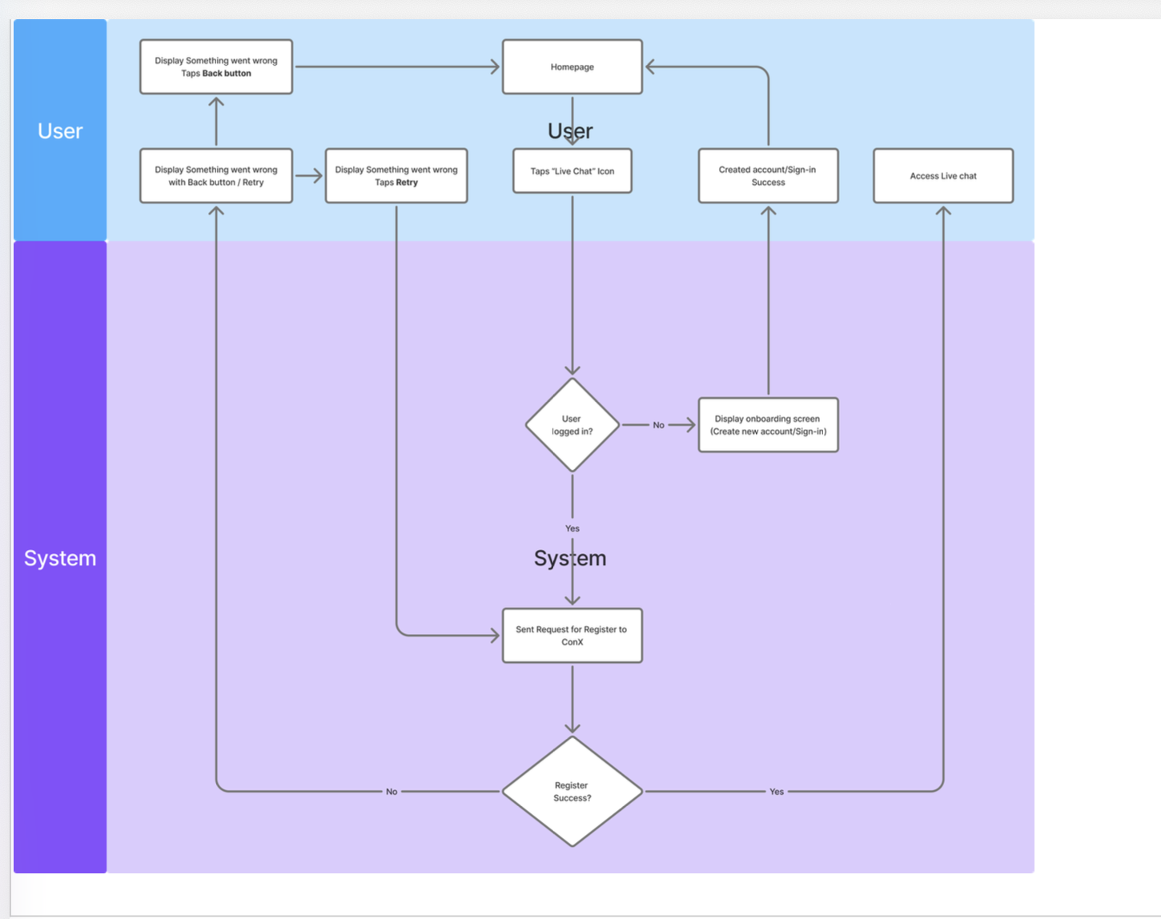

FAQ Integration
    - Narrative: Integrate the FAQ section to a dynamic system powered by ConnectX.
    - User Story: As a user, I want to see the most relevant and updated FAQs so that I can find answers without contacting support.
    - Acceptance Criteria:
- Dynamic Categories: Categories are fetched via API and sorted by "Important" status, then by total views, then by date.
- Article Detail: Displays rich text content directly from the ConnectX Knowledge Management system.
- Empty State: Display "No FAQs available" if no content is returned from the API.
    - Flow:
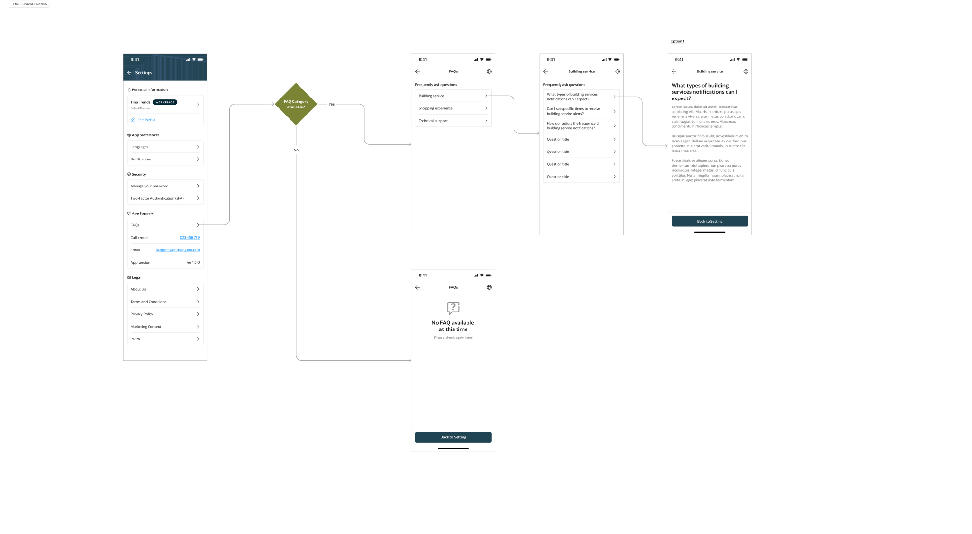

Email OTP
    - Narrative: Migrate the backend email provider from AWS to ConnectX for all OTP-related flows.
    - Acceptance Criteria:
- Flow Coverage: Includes Sign-up, Sign-in (2FA), Forgot Password, and Change Password.
- Rate Limits: Enforce 5 requests/second and 150,000 requests/day.
- Status Quo: Phone OTP and OTP validation logic (expiry/format) remain unchanged.

Support ConnectX Notification
    - Narrative: Ensure the application can handle and display notifications delivered via the ConnectX platform.
    - Acceptance Criteria:
- Specification: Delivery of a technical Notification Spec for ConnectX.
- Compatibility: ConnectX notifications must match existing app notification styles.
- Regression Testing: Verify that existing app-triggered notifications continue to function as expected.

Limitations
The following limitations apply to the implementation of the Live Chat, FAQ, Email OTP, and Notification integrations:
- OTP Rate Limiting: The Email OTP delivery service is strictly subject to a maximum throughput of 5 requests per second and a daily volume cap of 150,000 requests per day.
- Live Chat Access Restriction: The Live Chat feature is only available to authenticated users. Guest users or unauthenticated visitors must successfully sign in or create an account before the system initiates the ConnectX registration and opens the chat interface without notification.
- Dependency on ConnectX Services: The functionality of the Live Chat, dynamic FAQ fetching, and Email OTP delivery is entirely dependent on the availability, responsiveness, and uptime of the ConnectX platform’s APIs and SDK.
- Phone OTP Exclusion: This technical implementation is limited to the migration of Email OTP only; the existing Phone OTP service and its associated validation logic remain "as-is" and are not modified under this scope.
- Notification Scope: For the ConnectX Notification integration, the scope is limited to providing the technical specification and performing QA verification to ensure existing notification triggers remain functional; it does not include the creation of new server-side notification business logic.

Out of Scope
The following items are explicitly excluded from the project scope for the ConnectX integration:
- Phone OTP Service: Any modifications, maintenance, or service provider migrations for SMS/Phone OTP delivery. This service remains "as-is" and continues to function via existing providers.
- OTP Validation Business Logic: Changes to existing OTP validation rules, including expiry duration, resend cooldown timers, or character format requirements.
- ConnectX Backend & Content Management: Initial setup, configuration, or administrative management of the ConnectX platform.
  - Authoring, translating, or data entry of FAQ content within the ConnectX Knowledge Management system.
  - Configuration of agent groups, chat routing rules, or support hours in the ConnectX dashboard.
- Server-side Notification Logic: Implementation of new trigger events or business logic on the server-side to initiate notifications; the scope is limited to technical specification and QA verification of existing triggers.
- Deep SDK Customization: Modifications to the core ConnectX SDK source code. UI adjustments are limited to theme configurations supported by the official SDK.

Responsibilities
One Bangkok - Relevant Business Units (BU)
- Define overall feature requirements and support with information to facilitate smooth and efficient operations for Live Chat and FAQ.
- Act as the primary point of contact for providing the necessary FAQ content and support information to be hosted on ConnectX.
- Review and approve the application UX/UI design for the new modules.
- Attend User Acceptance Testing (UAT) to confirm and approve the design and functionality of the integrated services.
T.C.C. Technology Co., Ltd. (TCCT)
- Support necessary information and domain knowledge related to existing features (specifically existing OTP flows and notification triggers).
- Provide the required ConnectX API credentials and SDK documentation to enable Mtel to integrate the services.
- Coordinate with ConnectX for platform-side configurations, including daily rate limits and service quotas.
- Support the Mtel team during System Integration Testing (SIT), User Acceptance Testing (UAT), and Production Validation Testing (PVT), particularly for data synchronization and service migration validation.
- Provide necessary information and support for the preparation of approval and sign-off documentation.
Mtel (Thailand) Co., Ltd.
- Perform requirement gathering and clarification with relevant stakeholders.
- Execute UX/UI design and frontend development for the Live Chat interface and dynamic FAQ screens.
- Implement application-side integration with ConnectX APIs for user registration, FAQ fetching, and Email delivery.
- Develop and implement rate-limiting and error-handling logic for the migrated Email OTP service.
- Conduct and support System Integration Testing (SIT) and User Acceptance Testing (UAT) to ensure all in-scope integrations function correctly.
- Deliver updated technical documentation, including the Notification Specification and Scope of Work.

ConnectX
- Provide stable and accessible API endpoints and SDKs for Live Chat, FAQ, and Email services.
- Ensure the platform meets the performance requirements for high-volume Email OTP delivery (up to 150,000 requests per day).
- Provide technical support and troubleshooting for any platform-side issues during integration.

Variables and Constraints

External Factors
- ConnectX API Stability: The project timeline and functionality are dependent on the availability and performance of ConnectX production and UAT environments. Any downtime or unexpected API changes from ConnectX may impact the delivery schedule.
- Third-Party Rate Limits: The implementation must strictly adhere to the pre-defined quota of 150,000 requests per day and 5 requests per second. If business requirements change to exceed these limits, additional commercial and technical discussions with ConnectX will be required.
- Network Infrastructure: Successful integration assumes that the network path between the Mobile App backend and ConnectX endpoints is stable and whitelisted as required..

Internal Constraints
- Service Migration Window: The transition from AWS Email service to ConnectX must be coordinated with a maintenance window to ensure no OTPs are "lost" during the DNS or service switch-over.
- Backward Compatibility: All changes must ensure that existing notification and security logic (Sign-up, Sign-in, etc.) remains fully functional. Regression testing is mandatory for all existing modules.
- Security & Compliance: The handling of user data during the "Registration" step for Live Chat must comply with One Bangkok’s data privacy policies. Only the minimum required user profile data will be shared with the ConnectX SDK/API.
- Design Consistency: The Live Chat and FAQ user interfaces must align with the existing One Bangkok Design System and Figma specifications provided for this release.

Deliverables

Functional Deliverables
    - Live Chat Integration: A fully integrated "Live Chat" button in the app navigation, including the automated registration flow for authenticated users and redirection for guests.
    - Dynamic FAQ Module: A dynamic FAQ landing page and detail view that fetches, sorts, and displays content directly from the ConnectX Knowledge Management system.
    - Migrated Email OTP Service: Updated Sign-up, Sign-in, Forgot Password, and Manage Password flows that route Email OTPs through ConnectX with enforced rate limits.
    - ConnectX Notification Support: Ability for the mobile application to receive and display push notifications triggered by the ConnectX platform.

Technical Deliverables
    - API & SDK Integration: Implementation of ConnectX SDK and integration of specific APIs for User Registration, FAQ fetching, and Email delivery.
    - Rate Limiting Engine: Server-side and client-side logic to manage the 5 req/sec and 150,000 req/day caps for Email OTP.
    - Mobile UI/UX Enhancements: Updated native screens for the FAQ article list and detail views, as well as new error/limit state screens for OTP.

Documentation Deliverables
    - Scope of Work Document
    - Technical Design Document
    - UAT Sign-off Document
    - User Manual Document

Testing Deliverables
    - Test Plan
    - Test Scenarios & Test Cases
    - QA Test Report
    - UAT Support & Defect Fixes

Deployment & Handover Deliverables
    - Release Notes
    - Knowledge Transfer Session

Agreed and approved by:
T.C.C. Technology Co., Ltd.

___________________________________
(Raphat Chuenchamanan)
raphat.c@tspacedigital.com
___________________________________
(Nuttanicha Punyahiranthamrong)
nuttanicha.p@tcc-technology.com

Proposed by:
Mtel (Thailand) Co., Ltd.

___________________________________
(Khempaphat Amarathanad)
khempaphat.ama@mtel.co.th
Initial by:
___________________________________  (Shao Shyang Chuang)  michael.chu@mtel.co.th | ___________________________________  (Chakorn Punpatch)  chakorn.pun@mtel.co.th

Appendix 1: Live Chat Design Flow

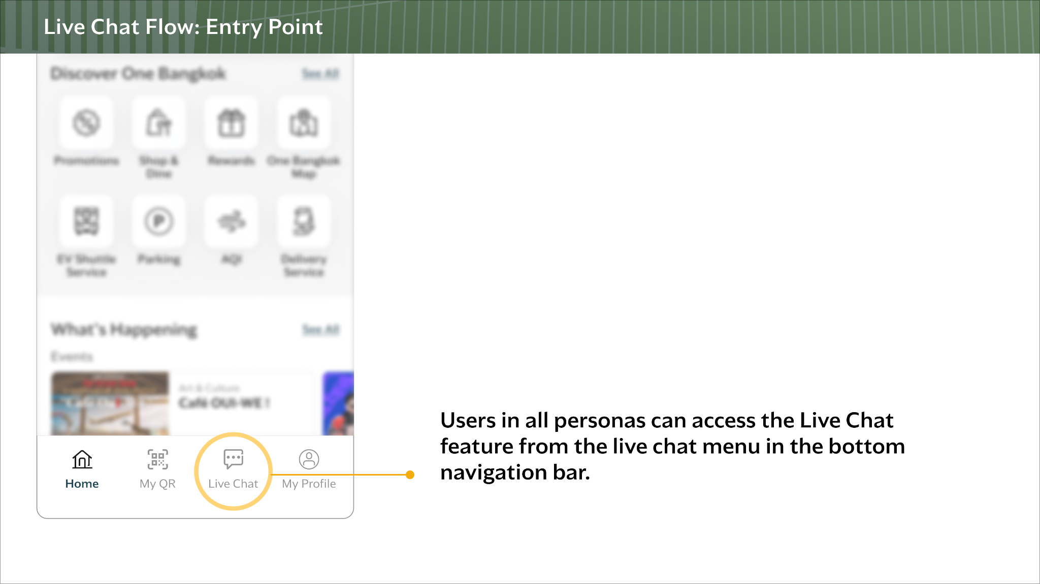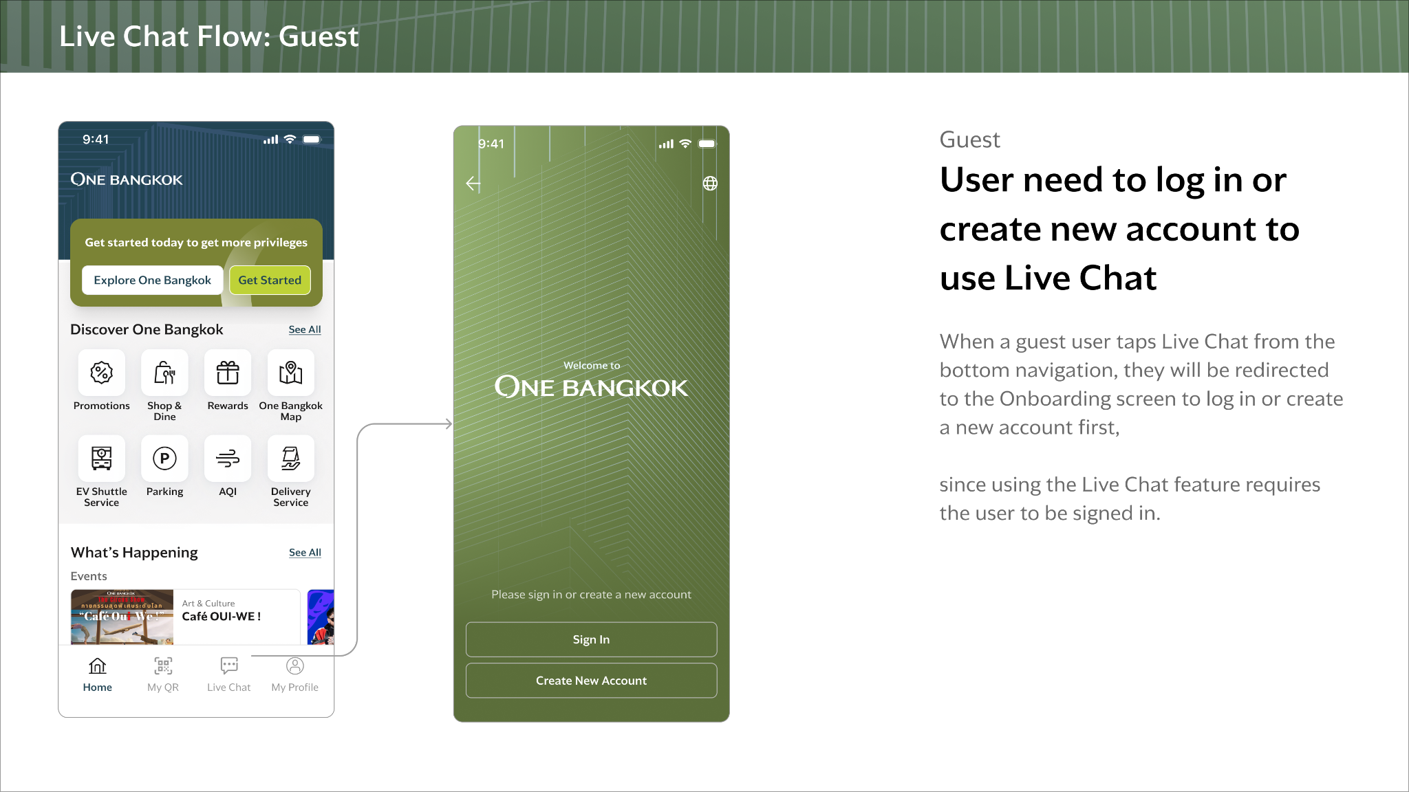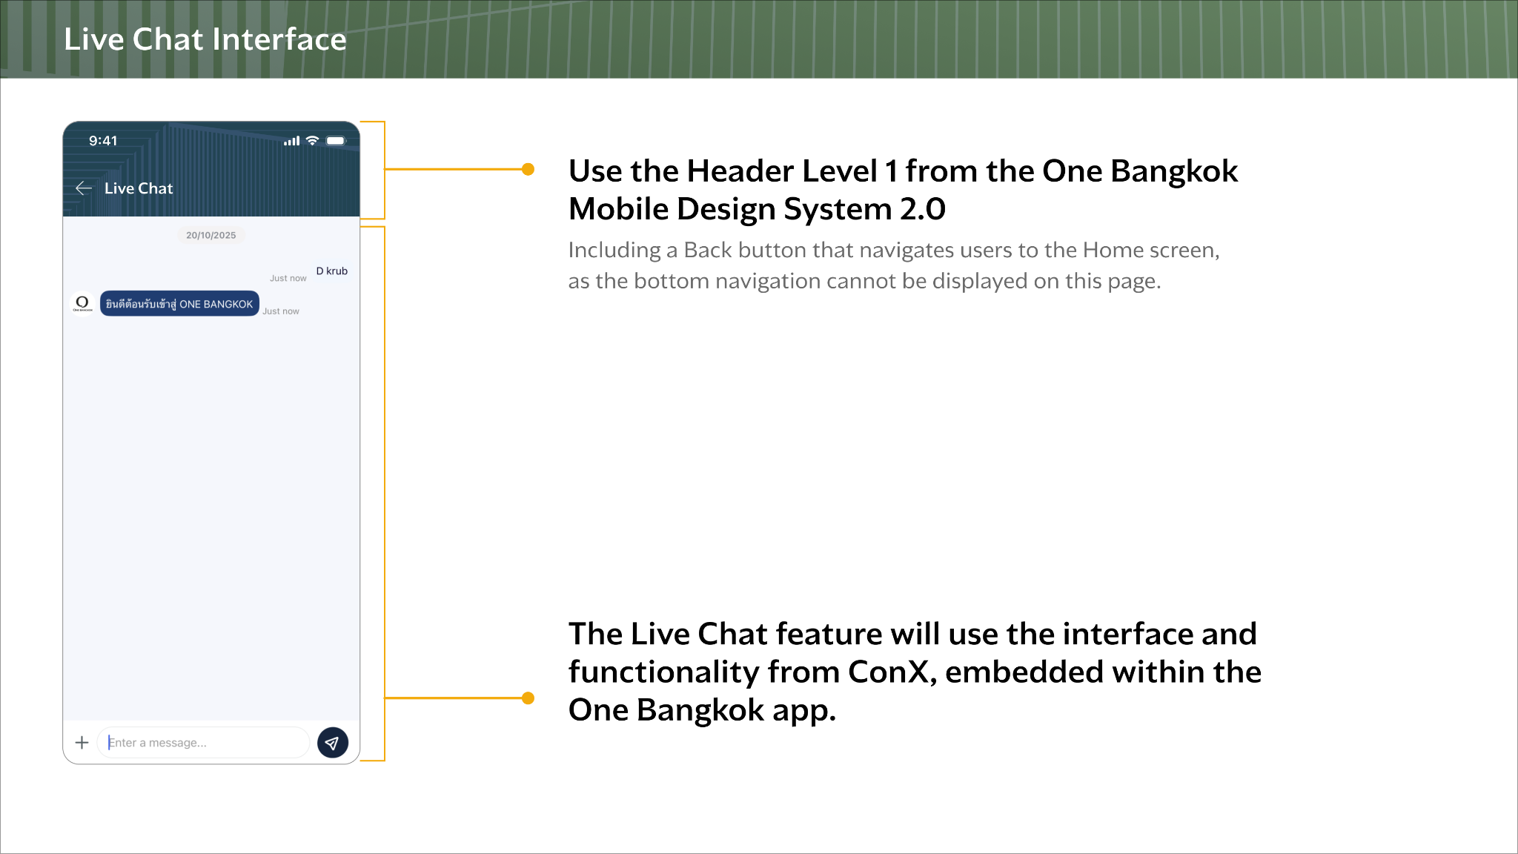

Appendix 2: FAQ Design Flow

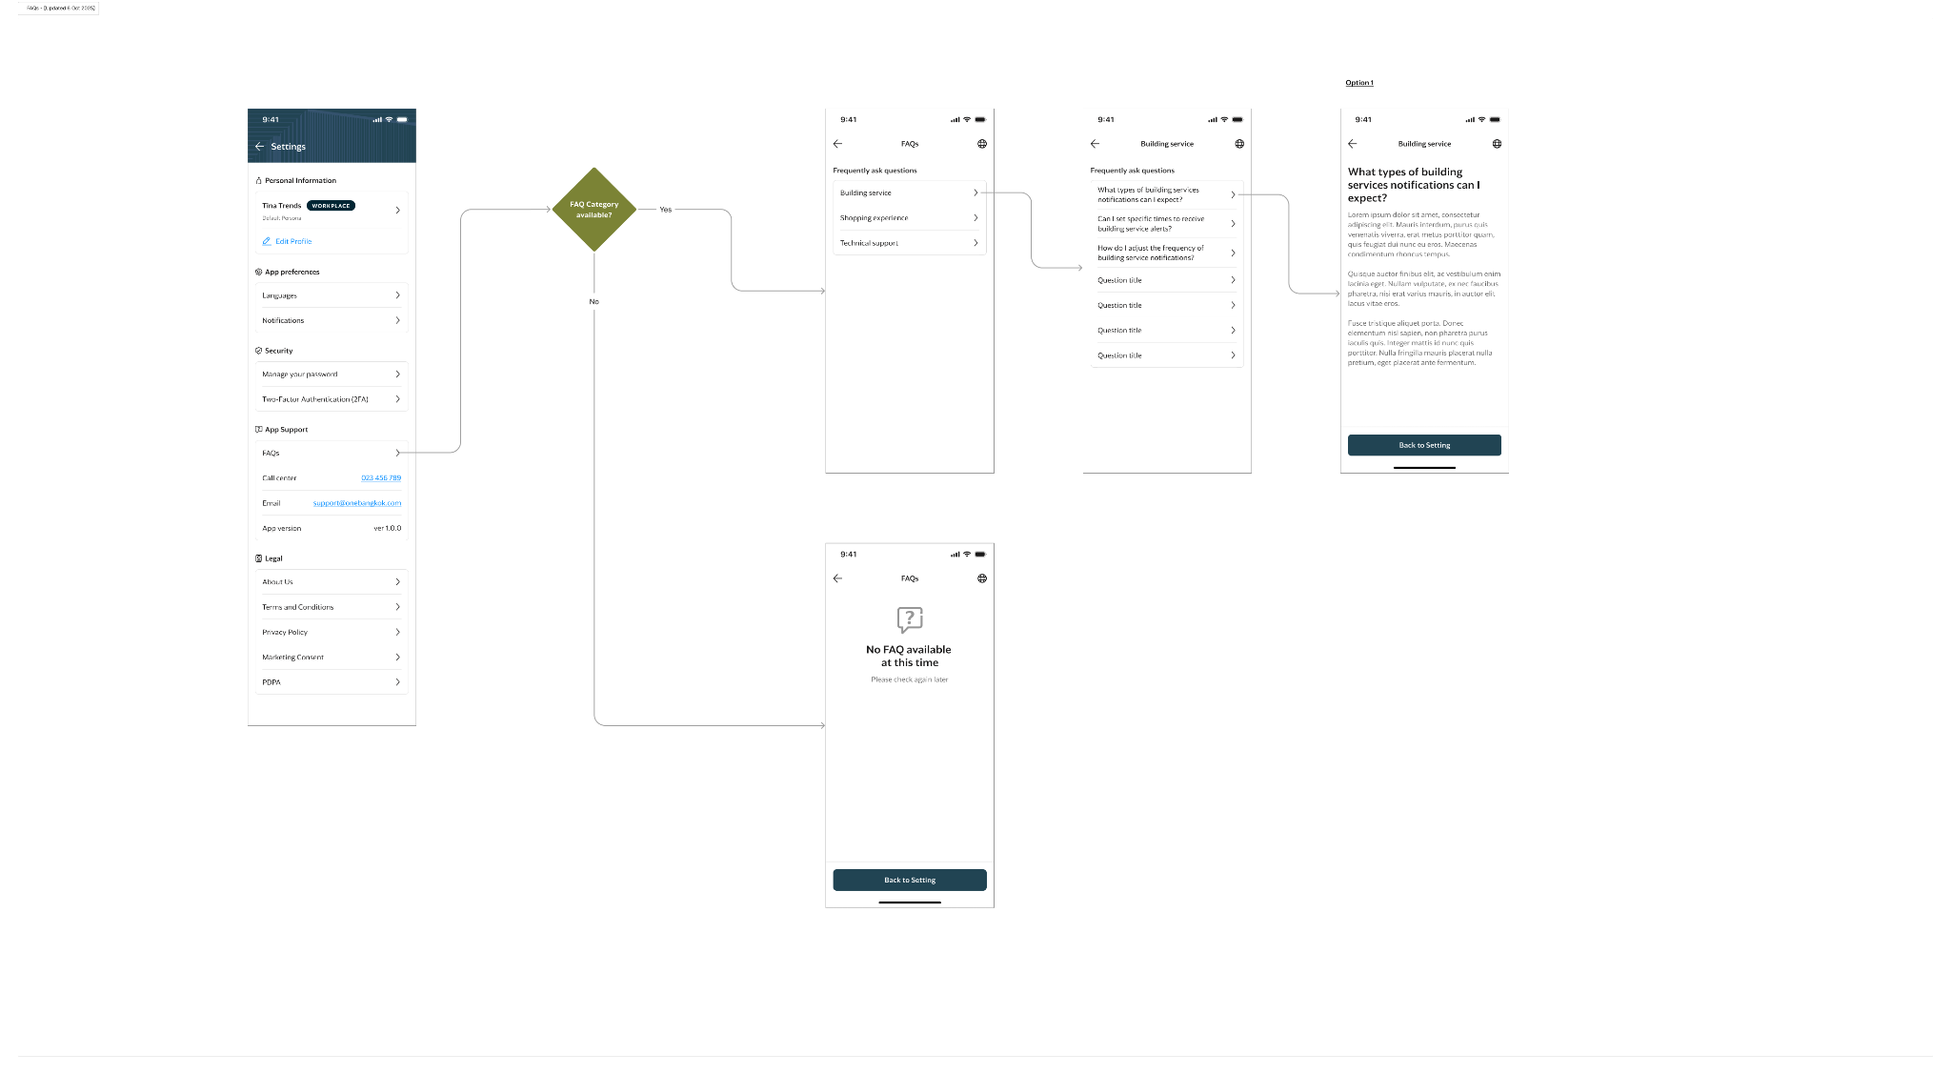

Appendix 3: Email OTP

